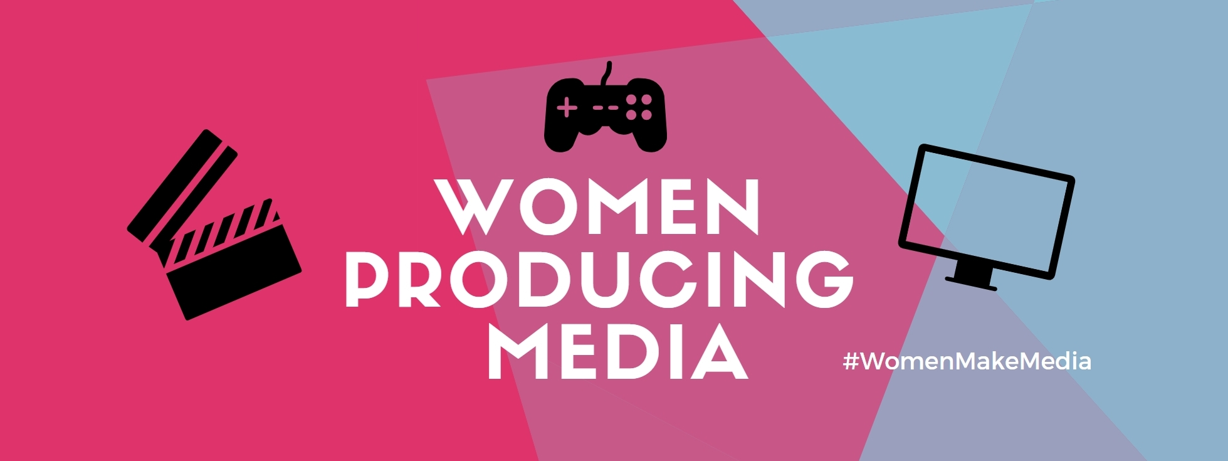
For Immediate Release: For More Information:
Tuesday, March 19, 2019 Katrina Stovold
press@womenproducingmedia.com

Five amazing women speakers are coming to UCC to talk about the challenges and opportunities facing women who produce media
CORK, IRELAND – On Friday, March 22, 2019, the first Women Producing Media symposium will be held at University College Cork. Improving gender balance and diversity in production crews is an important part of the equation when it comes to modernising representation on screen and in print.
The event will take place in Room 212 of the O’Rahilly Building at UCC from 3 to 5 p.m. Women just starting out in media, experienced women who would like to network, and academics interested in diversity and inclusion in media are encouraged to attend. The topics will be addressed in a way that will be meaningful creative workers, the public, and academics.
Our speakers are Brenda Romero, game designer and Fulbright recipient; Joanna Dukkipati, publisher and online radio producer; Shubhangi Karmakar, writer, medical researcher, and activist; Dr. Sarah Arnold, lecturer in Media at Maynooth; and Prof. Brenda Murphy, researcher in gender and media at the University of Malta.
Women account for 50% of film audiences around the world, yet of the top 100 grossing films of 2018, women only represented 4% of directors, 15% of writers, and 3% of cinematographers. Similar disparities can be found across all aspects of digital media production. Every awards season there are ‘firsts’ for women and minorities, but their contributions should be part of the norm, rather than the exception.
“We need to do more than simply break the ‘glass ceiling’. We need to restructure industries that have consistently elevated dominant voices and silenced minorities. Women supporting women in media is one of the ways we can change what is on screen to reflect our lived realities.”
– Katrina Stovold, former visual effects worker and current Maynooth PhD student
MORE

This is the first event by Women Producing Media and was done with the support of the Women’s Studies programme at UCC. The response has been overwhelmingly positive. It is intended to be a recurring event, with plans to expand internationally at a later date.
More information can be found at womenproducingmedia.com.
- Register on Eventbrite at http://bit.ly/WPM_UCC
- Follow us on Twitter: @WomenProducing
- Facebook event: https://www.facebook.com/events/1092762197591255/
- Hashtag: #WomenMakeMedia
We welcome press inquiries and invite photographers and journalists to attend.
# # #

